SIGCCSE In-Cooperation Process

1. **CCSC Vice President** is responsible for submitting SIGCSE In-cooperation request.
2. Best to submit the **fall conferences by the spring meeting** and the **spring conferences by the fall meeting**. SIGCSE requires that approval for In-cooperation be approved before advertising the In-cooperation agreement.
3. Need to **gather conference information approximately 6 months before the conference date**. May need to remind Regional Reps to have conference web sites updated. Most information can be “scraped” from the conference web site and the web sites for the conference chairs and the program chairs.
   1. See included “SIGCSE Incooperation Data” as a starting point.

* 1. **SIGCEs requires conference that Conference Chairs and Program Chairs must be ACM and/or SIGCSE members**. If possible, significant effort can be eliminated if conference chairs and program chairs provide their ACM/SIGCSE ID #.
  2. For **each conference** gather the following:
* Conference Name in the format “CCSC-XX ’20: 2020 Computer Science Conferences” where XX is the conference letters (i.e., SW, MW, MS, NE, etc.)
* Dates
* Website
* Location
* City
* State
* Country

For both **Conference Chair** & **Program Chair** gather the following OR get their ACM/SIGCSE ID:

* First
* Last
* Affiliation
* Street
* City
* State
* Zip
* Country
* Email
* Phone

Conference statistics: (estimates)

* Number of sessions and papers for conference
* Conference attendance
* Conference budget and expenses

Here are some basic estimates based on the size of conferences, but you can review past conferences, budget’s or minutes to get better estimates:

|  |  |  |  |
| --- | --- | --- | --- |
|  | Small | Medium | Large |
| Sessions | 2 | 3 | 4 |
| Papers | 6 | 9 | 12 |
| Attendance | 50 | 100 | 150 |
| Revenue | $7,000 | $10,000 | $12,000 |
| Expense | $6,500 | $9,000 | $10,000 |

1. Request updated **Certificate of Insurance** from the CCSC Treasurer. CCSC currently renews insurance in early November.
2. Gather **Publisher Information** for the *Journal.* Contact information should be that of the **current Publishing chair**. Example:

The Consortium for Computing Sciences in Colleges

1600 University Avenue, Bolivar, MO 65613

blue@sbuniv.edu

417-328-1676

1. You will need your **ACM/SIGCSE** number and contact information.
2. Create a Statement of Understanding for each conference (save as pdf).
   1. You will need the conference name, dates and location.
   2. The current address for CCSC is currently our Treasurer, Brian Hare’s: 5110 Rockhill Road, Kansas City MO 64110
   3. Past Statement of Understanding’s will be included with these instructions.
   4. A mail merge using data from an excel spreadsheet can simplify this process, but it may be just as fast to edit the individual documents and save as .pdf.
3. If you review the SIGCSE In-Cooperation agreement you will see that is asks for a follow-up report. Will Mitchell, who did the agreements until 2016 (before it was handed over to the VP), reported that in his 15 years of submitting we have never sent in the post report.
4. After collecting the conference data, the certificate of insurance and creating the hold harmless agreements you can then complete the forms

**Start at** [**http://cms.acm.org/incoop/cms_incoop.cfm**](http://cms.acm.org/incoop/cms_incoop.cfm)

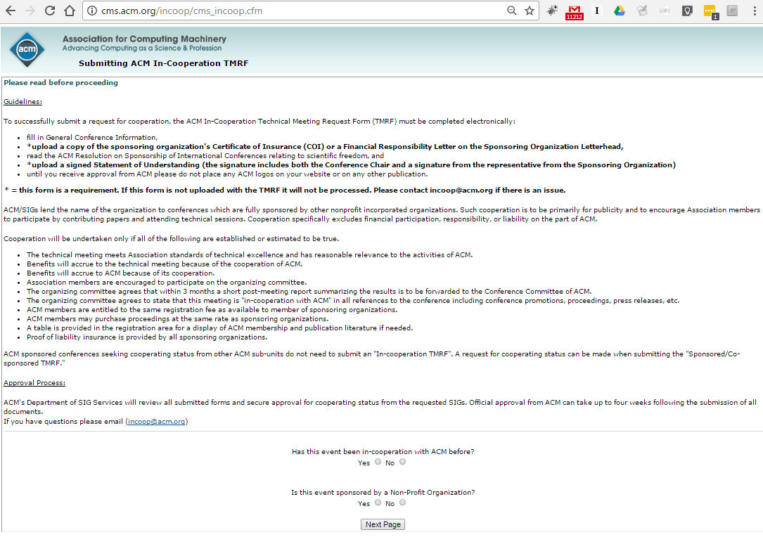

Choose **Yes for both** and select **Next Page**

Enter **CCSC** and **year** and select **Continue**

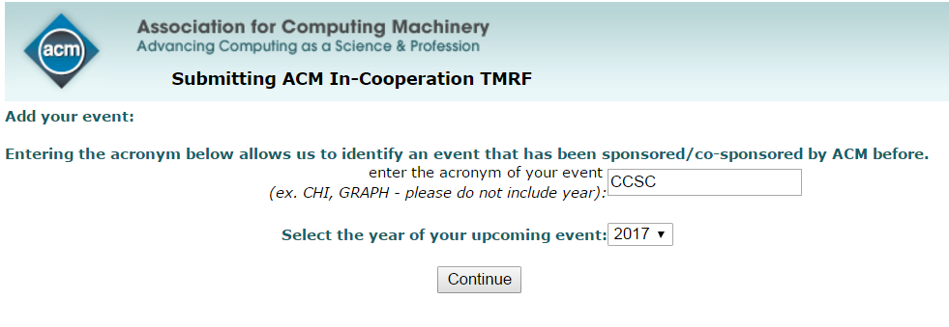

**List of CCSC conferences will appear**. Select **previous conference** to update (i.e., CCSC MW ‘16 to enter new data for CCSC MW ‘17) and new page will appear to enter data.

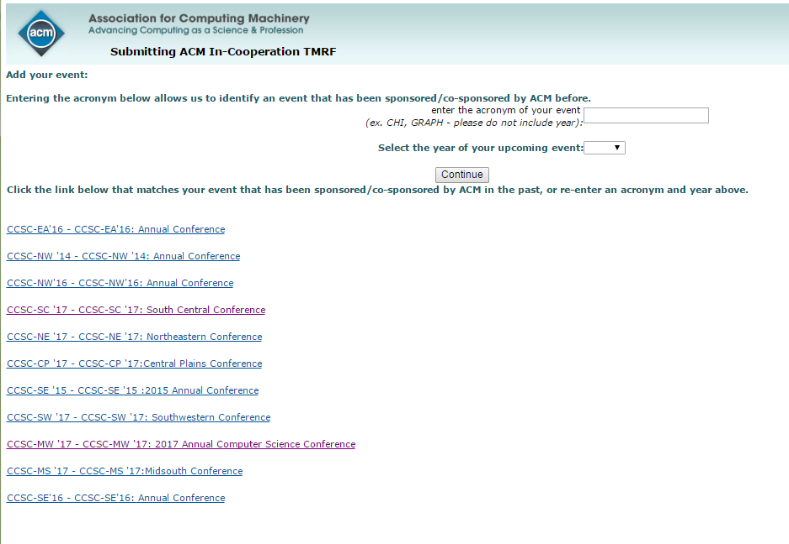

**Enter Event Title, Conference, 12 month frequency, start date, stop date, and conference URL.**

Note: use Event Title format CCSC-MW '17: 2017 Annual Computer Science Conference

CCSC-MW '17: 2017 Annual Computer Science Conference

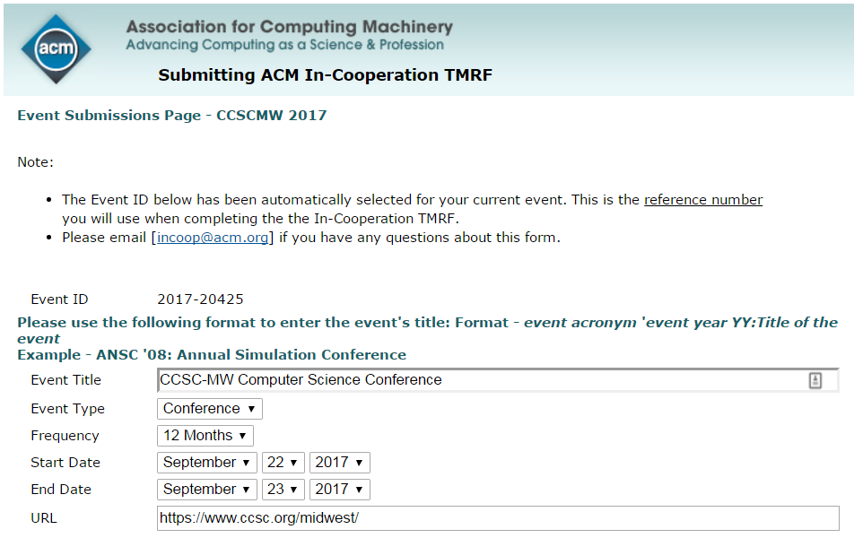

**Location and Financial Responsibility**

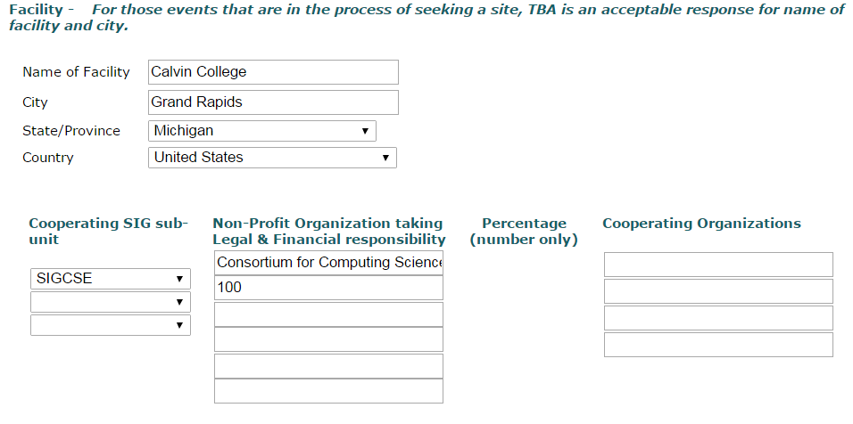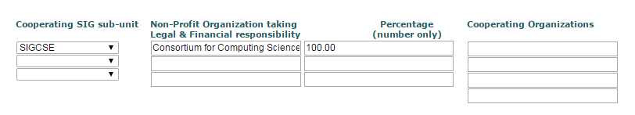

**Anticipated Attendees, session, papers, income, expenses**

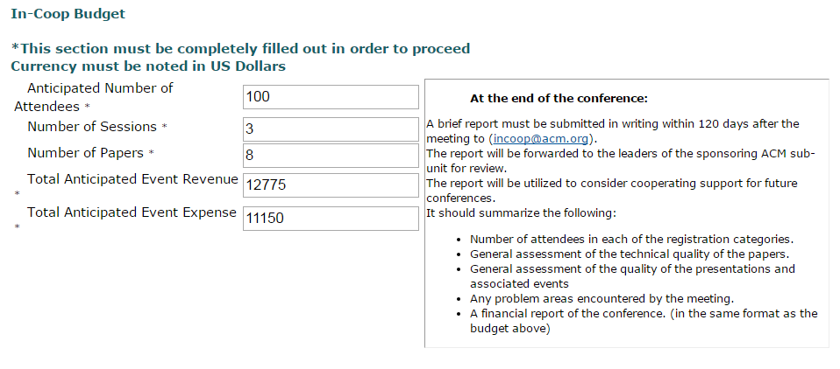

**Event Proceedings**

Consortium for Computing Sciences in Colleges

1600 University Avenue, Bolivar, MO 65613

blu@sbuniv.edu

417 328-1676

A wide variety of topics relating to Computer Science and Computer Science Education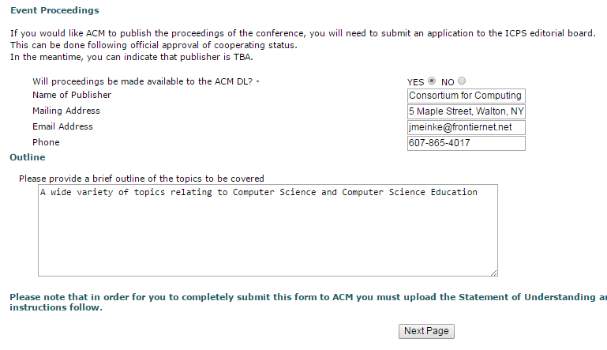

**Two pages of Acknowledgments**

Page #1

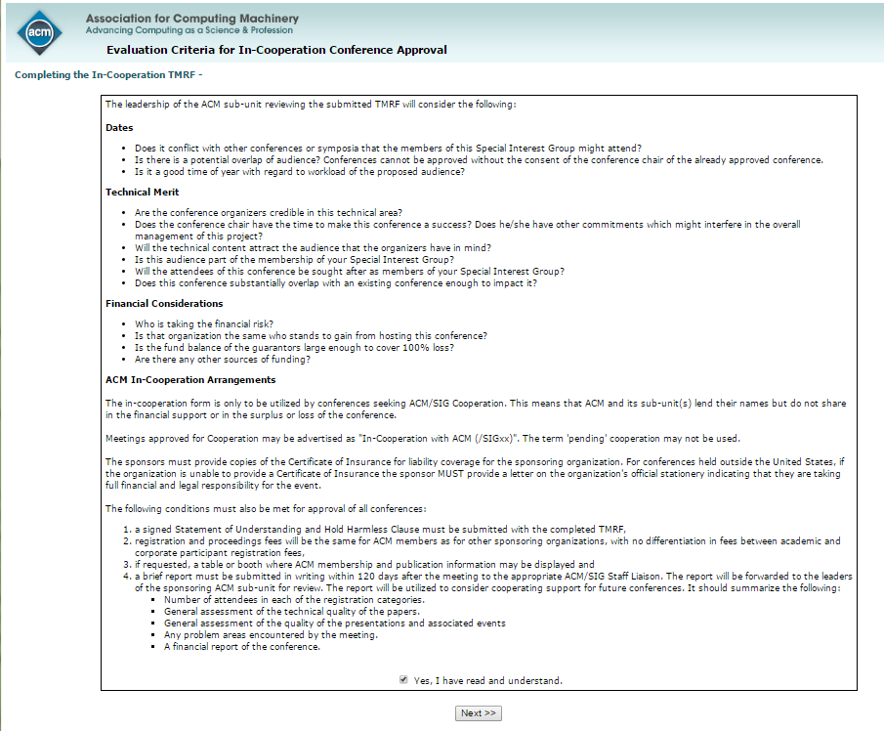

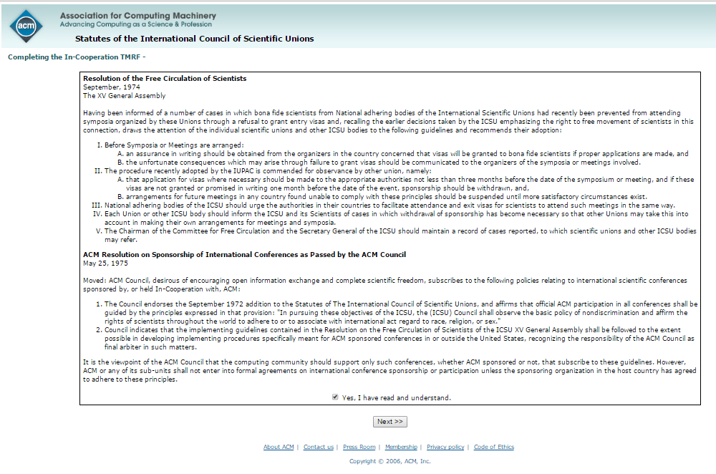**Page #2**

**Enter Chair, Program Chair (i.e., could be Papers chair)** **and yourself as Steering Committee Member** (Note: easier if you have ACM #’s)

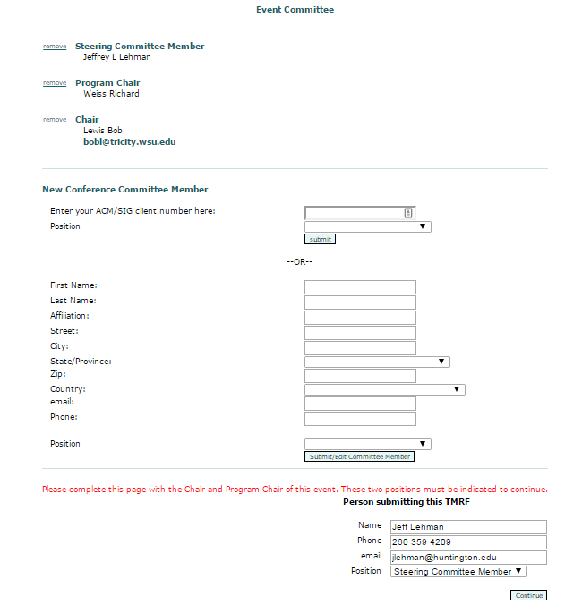

**Upload Certificate of Understanding and Statement of Understanding/Hold harmless clause.**

